0653422 HW7 林容伊

1. gaussian filter  
   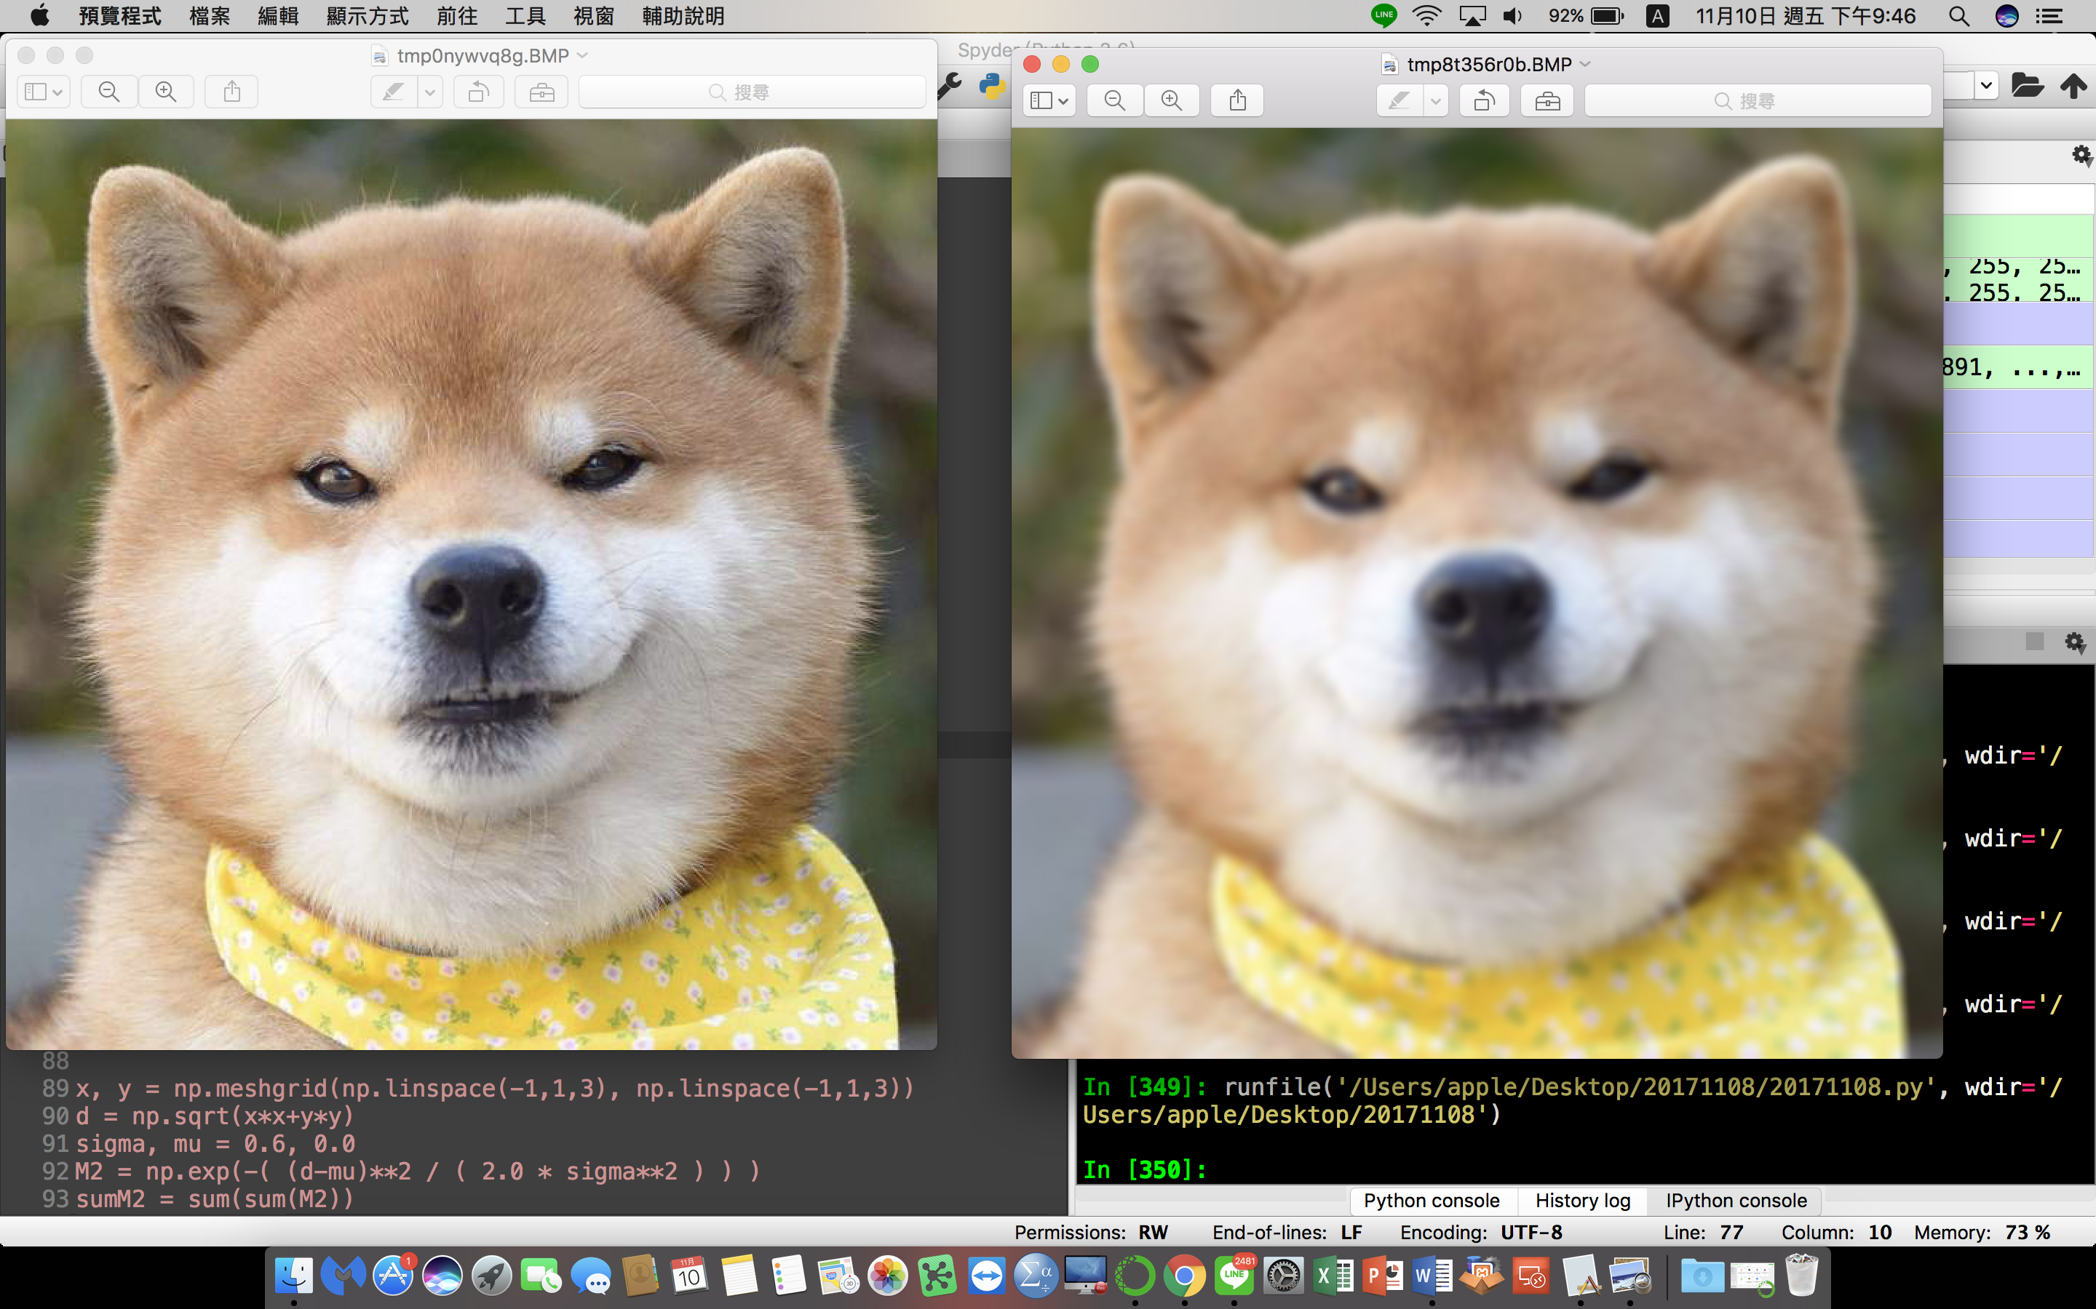
2. motion filter  
   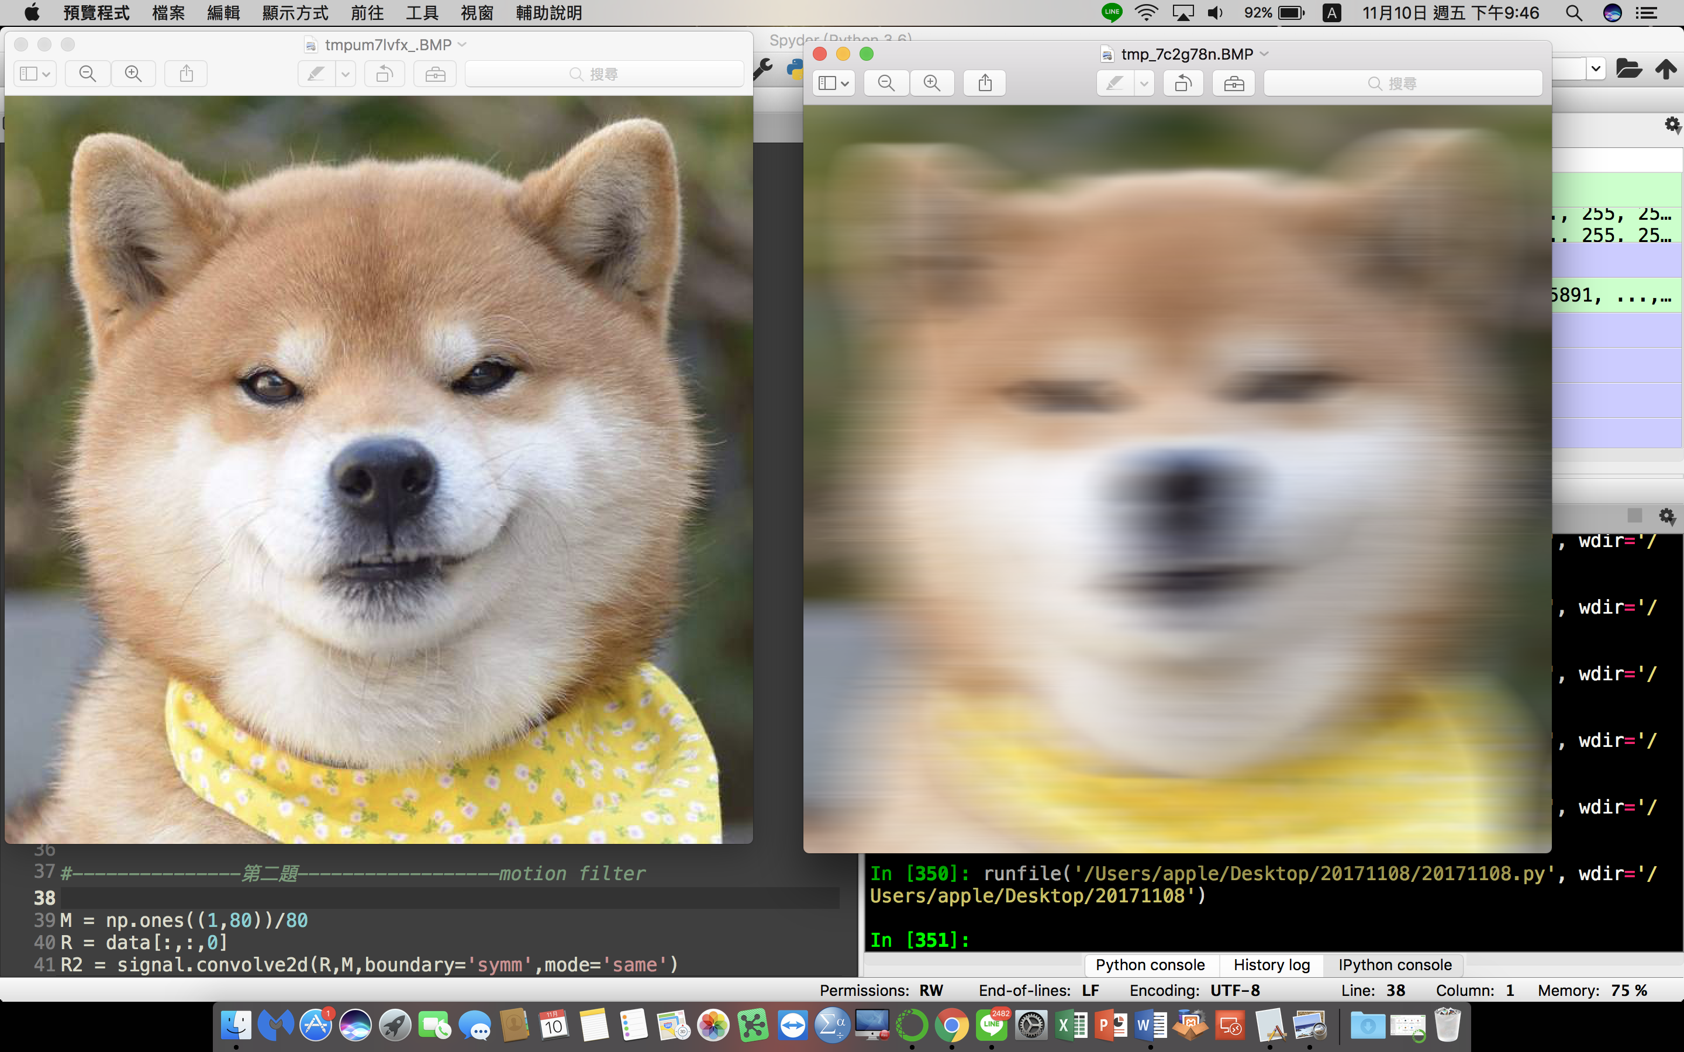
3. sharpening filter  
   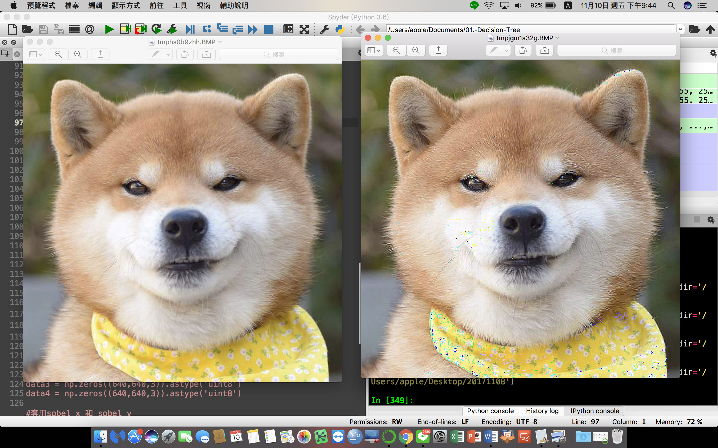
4. 畫出edge圖  
   